Player
1
START
SING A NURSERY RHYME WHILE STANDING ON ONE LEG

DO 4X STAR JUMPS
PLANK HOLD TO FRONT SUPPORT x5
MOVE AHEAD 1 SPACE
HOP-SCOTCH FROM 1 - 20
SUPER SKIP
MOVE AHEAD
EVERYONE COUNT FROM 40 BACKWARDS
MOVE BACK
2
SPACES
DO
5
TUCK
JUMPS
TOUCH
SOMETHING
SHOW OFF YOUR BEST GYM MOVE! (BE SAFE)
SKIP
ONE
TURN
NAME 5 MOVES FROM THE
GYM IN 10
SECONDS
THROW & CATCH A BALL WITH ONE HAND x3

DO
10
BUNNY HOPS

LAY IN DISH SHAPE FOR 10 SECONDS

ACT LIKE
A MONKEY 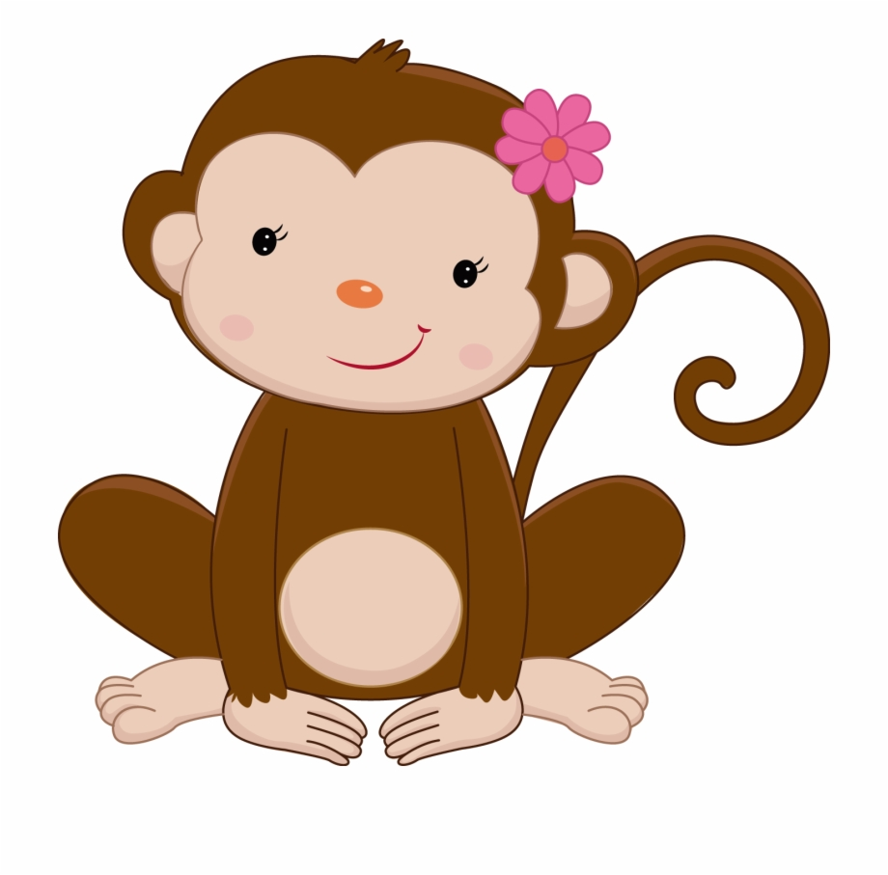
Oh No!
Go Back
SING THE
ALPHABET 
TOUCH SOMETHING
Move Ahead 1 Space
TURN FROM BACK SUPPORT TO FRONT SUPPORT x5
EVERYONE MAKE THE SOUND OF A FROG WHILE ACTING LIKE AN ELEPHANT
OH NO! GO BACK TO THE START!
SAY OUT LOUD “HANDSTAND, HEADSTAND” x5 AS FAST AS YOU CAN!
DO
10
SQUAT JUMPS
PICK SOMEONE TO MISS A TURN ☹
JUMP SIDE TO SIDE FOR
20 SECONDS

KENNYLANDS
RECREATION 8-10

BOARD GAME
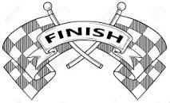

Player
2

Rules Box
1) Roll a dice and move your counter to the square.

2) You must complete the task or miss a turn ☹

3) Two or more players can be on the same space.

4) Continue to play until someone reaches the finish, then see who will finish second, third, etc.

5) GOOD LUCK everyone and have fun!!!

Player
3

Player
4

